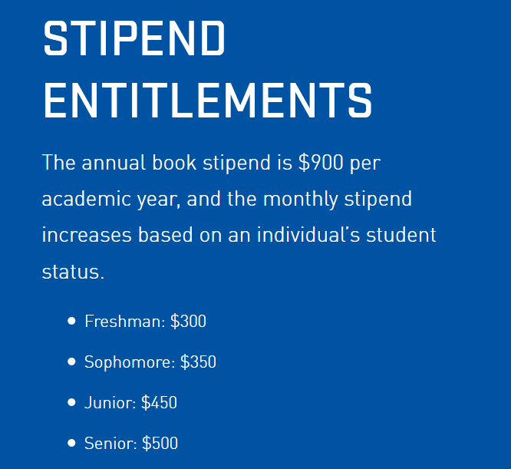
High School Scholarships
- TYPE 1
  - Pays full (100 percent) college tuition and authorized fees at any public or private institution with an Air Force ROTC detachment.
  - Type 1 selectees will also receive a monthly living expense stipend and an annual book stipend.

- TYPE 2
  - Pays up to $18,000 per year in college tuition and authorized fees at any public or private institution with an Air Force ROTC detachment.
  - Scholarship payment is further capped at $9,000 per semester or $6,000 per quarter.
  - Type 2 selectees will also receive a monthly living expense stipend and an annual book stipend.
- TYPE 7
  - Pays full (100 percent) college tuition and authorized fees (capped at the in-state tuition rate) at a public institution with an Air Force ROTC detachment. Type 7 selectees will also receive a monthly living expense stipend and an annual book stipend.
  - Students offered a Type 7 scholarship will be given the option to convert their scholarship to a three-year Type 2 scholarship that can be used at out-of-state or private schools. A three-year Type 2 scholarship will start during the sophomore year of school.

